_________________________________________________________________________________________

Questions to ask when writing SMART goals:
- Specific: Ask yourself the questions: who, what, when where and why? What will the patient or caregiver do? Customize the goal for the member’s issue(s). Avoid vague descriptions.

- Measurable: How will progress be measured? How will you & the member know it’s been achieved?

- Actionable/Attainable: Is the goal reasonable and achievable? Can this really happen? Set realistic goals for the client’s physical, cognitive, social and environmental barriers.

- Relevant: Why is achieving this goal important? Is the goal meaningful? Establish goals in partnership with the client.

- Time Bound: When will the goal be achieved? What is the timeframe for achieving the goal? (Think about the time frame-is it justifiable for the goal attainment?)

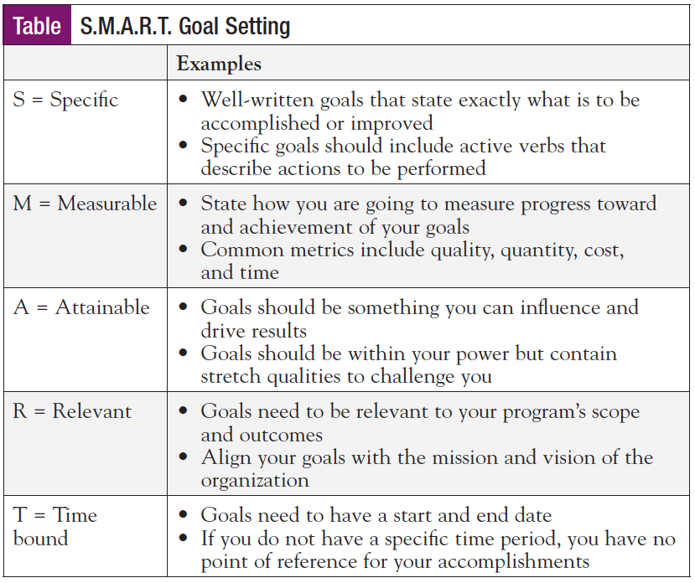

- Timeframes should be realistic to the goal-this hasn’t changed

- Just because the care plan does not officially have to be updated yearly-it does not mean that the time frame of a goal be pushed out for a year.

- Once you clone & close-just the problems are pulled over-new goals and action steps must be re-established so that the goals will be in SMART format & action steps identify who is doing the action..is it the member? The provider? The HHS?
Avoid “Blanket” goals

- Care Coordination-Your action steps should meet Core Services of HH program: Comprehensive Care Management.
  - Care Coordination and Health Promotion.
  - Comprehensive Transitional Care.
  - Enrollee and Family Support.
  - Referral to Community and Social Supports.

- Transition of Care/Discharge- use only when the member had or a frequent flyer for inpatient /ED admissions: Do not use:
- To facilitate effective transitions of members who are moving between different sites of care while maintaining patient safety and coordinating health management.

- Gaps in Care-Add only when the member has a gap in care

- Community Resources: frequently see: Member will increase knowledge of community resources by 7-1-22. Resources should be attached to a problem.

Avoid goals for “what if?” or “just in case”

Goals Should Be Member Centered

- What does the member want or need to achieve?

Pain Goal Example:
Goal | Feedback | Rewritten Goal
Over the next 12 months the mbr will communicate and work with Dr. Aleggio, the HHS, and other care team mbrs to find ways to better manage and treat his pain, as evidenced by decrease in ED visits | Is the goal to reduce ED visits caused by his pain or improve in communication? How will you know there is decrease in ED visits? | Ex. Within the next 6 months the member will learn and apply 1-2 strategies to reduce his pain level from 7/10 to 5/10.  Interventions: member will collaborate with his health care team to learn strategies to reduce his pain  Member will communicate with his provider on what is and is not working to decrease his pain or  Member will contact his provider when his pain increases to decrease ED admissions  If the member has a hard time communicating with his provider-is there a good relationship with the provider does he need to change providers?
Example of Non-Member Specific Goal
Over the next 12 months HH2 will help foster communication between members and medical providers as barriers arise | This goal spells out what HHS will do. What does the member have to do? What is the goal? Does the member need to learn on how to communicate with his provider?

Example-helping member identify triggers that cause bouts of depression exacerbation

In the next 6 months member will increase knowledge of depression symptom triggers for herself | How will this be measured? How will you know she increased her knowledge? | .In the next 6 months Jane will learn the triggers that cause her depression as evidence by documentation in her anxiety workbook.

